The 11th EU-China Business and Technology Cooperation Fair
Qingdao, 6-8 November 2016

Hotel Reservation Form

Official Hotels :
1. 青岛香格里拉大酒店Qingdao Shangri-La Hotel ★★★★★
No.9 Xianggang Middle Road, Qingdao China P.R
http://www.shangri-la.com/cn/qingdao/shangrila/
Room Rate |  |  | Qty | Picture
A | Deluxe Single Room  豪华大床房  38m² | 800RMB |  | 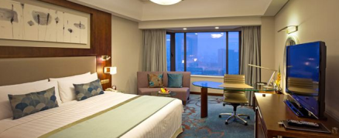
B | Double Room  标准双人房  38m² | 700RMB |  | 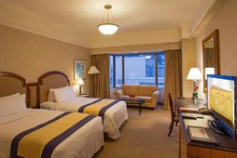

2. 青岛北海宾馆Qingdao Beihai Hotel ★★★★
No.7 Xianggang Middle Road, Qingdao China P.R
http://www.beihaishotel.com/
Room Rate |  |  | Qty | Picture
A | Deluxe Single Room  豪华大床房  30m² | 400RMB |  | 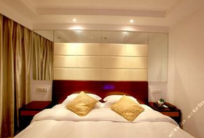
B | Double Room  标准双人房  25m² | 400RMB |  | 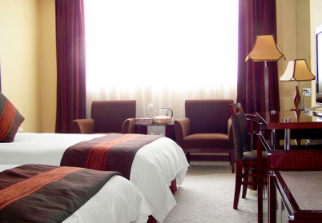

Remark:
- Pay on arrival;
- Rates shown above are per room and night and include 15% of service charge, 1 or 2 daily breakfast and tax;
- Free internet connection.
- During the period of the fair, the Check-out time is before 12:00 noon. Any delay in checking out before 18:00 without the consent of the hotel will be subjected to a charge for another half day and that after 18:00 will be subjected to a charge for another full day.

Guest information (add additional guest info if necessary)
First Name |  | Family Name
Gender |  | Organisation
Country |  | Passport Number
Mobile |  | Email
Arrival Date |  | Arrival Flight
Departure Date |  | Departure Flight
Smoking Room | ( ) yes ( ) no | Other requirements

Please complete the form and return to following contacts:

kevin_wang@eupic.org.cn zoe_zhao@eupic.org.cn

